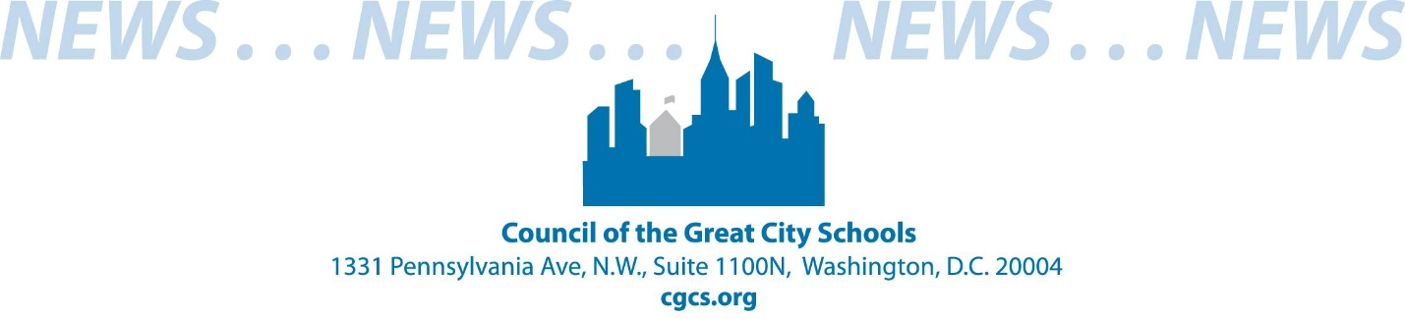

**FOR RELEASE** CONTACT: Tonya Harris

July 27, 2020 (202) 393-2427 or tharris@cgcs.org

**Council Files Amicus Brief Against Department of Education   
Diverting Money from Public to Private Schools During COVID-19 Pandemic**

***Urban Public Schools Will Lose Millions of Dollars Congress Allocated***

***To Help At-Risk Students***

WASHINGTON, July 27 --The Council of the Great City Schools, the nation’s primary coalition of large urban public-school districts, filed an *amicus curiae* brief with the United States District Court for the Northern District of California supporting the states and Council members filing suit against the U.S. Department of Education’s plan to divert hundreds of millions of dollars Congress intended to support public schools grappling with the COVID-19 pandemic to private schools.

In March 2020, Congress appropriated approximately $13 billion to elementary and secondary schools through the Coronavirus Aid, Relief, and Economic Security Act, (CARES Act) to help school districts address needs arising out of the COVID-19 pandemic. School districts were also required under the Act to allocate a portion of CARES Act funds they received to provide “equitable services” to private schools, just like they do under the federal Title I program. The amount was determined based on the number of low-income students residing in the district and attending private schools.

However, the interim final rule recently adopted by the Department would direct school districts to distribute funds ***not*** based on the number of low-income private school students residing in their districts, but based on the total enrollment of students attending private schools in the district regardless of their financial need.

The overall effect of the Department’s approach would divert hundreds of millions of

dollars of critically needed funds away from public school districts serving low-income communities to wealthier private schools at precisely the moment when schools are facing substantial budget cuts.

**Devastating Impact on Big-City Schools**

The effort by the Department of Education to rewrite the CARES Act would have a devastating impact on the nation’s big-city public schools as they prepare for the reopening of schools in the fall and work to keep students and staff safe. The diversion of funds to private schools, regardless of need, would dramatically reduce the funds available to public school districts that are members of the Council.

Sixteen Council member districts estimate that the amount of funds they would lose to private schools would range from about $628,000 to $6,485,000. The four Council member districts that are parties to the litigation – New York City Department of Education, Chicago Public Schools, San Francisco Unified School District, and Cleveland Metropolitan School District – said that they would lose about $53,000,000, $10,170,000, $1,740,000, and $822,952, respectively. Based on the poverty levels found in urban public schools, the Council estimates that its member districts could lose a total of about $292,000,000 of these much-needed, emergency resources.

Because $540,000 has been diverted to private school funding, Broward County Public Schools in Florida was not able meet the technology needs of schools as they transitioned to a virtual environment. The nation’s sixth-largest school district also had to reduce funds for professional

development and instructional materials.

If Baltimore City Public Schools must provide the additional $2,419,639 to private schools, then it will have to reduce the number of students that can receive Chromebooks to support distance learning by 6,050. The district would also have to reduce the number of students that can be provided a semester of tutoring by 3,252.

Charleston County School District in South Carolina was not able to provide the childcare services that the district’s teachers needed to support online instruction. The diversion of money to private schools would result in the school district not being able to purchase sufficient personal protective equipment (PPE) to support reopening and struggle to provide Wi-Fi devices for students living in areas with limited internet capability.

The $1.8 million the District of Columbia Public Schools will lose to private schools could purchase 2,100 additional devices for low-income students to support their virtual learning, while Oregon’s Portland Public Schools would need to cut more than $628,000 from

needed Chromebooks, safety supplies and materials.

“Public school districts face enormous challenges dealing with the global COVID-19 pandemic and funds made available through the CARES Act were intended to help schools offset the unexpected costs they were incurring to keep students and staff safe,” said Council Executive Director Michael Casserly. “Many of the schools in Council member districts serve disadvantaged communities and must address the digital divide to equitably provide on-line educational opportunities. The Department of Education’s unlawful rewrite of the CARES Act severely undermines this critical work.”

###